Looking for interesting amateur radio reading material

Try: www.k9ya.org

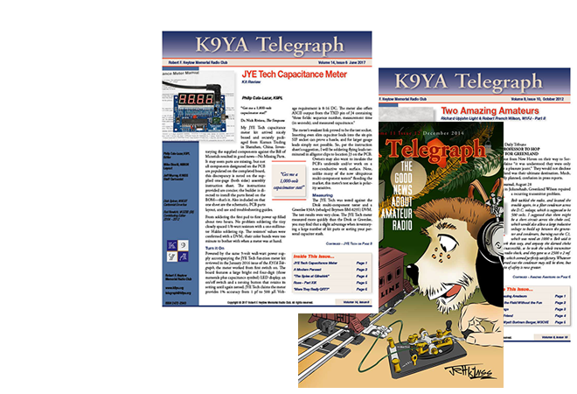
Thanks to VK4SY for this contribution.

